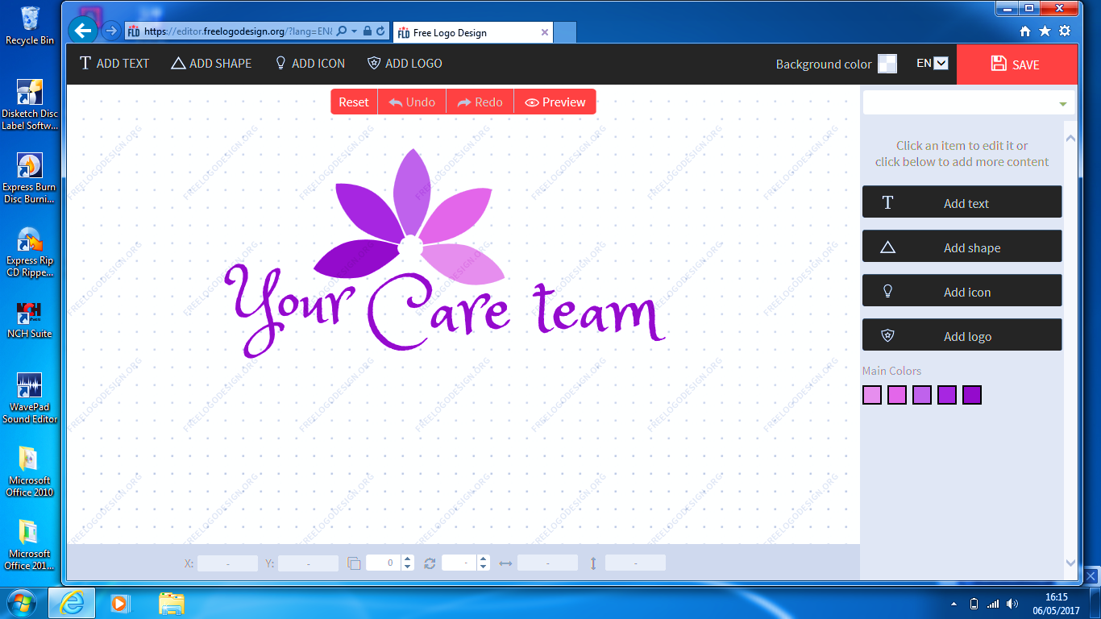
Safe Care and treatment with Your Care at heart

As a support worker, you will be responsible for supporting people with their goals based within their home environments or local community. Activities of support vary from daily living skills, travel escorts, teaching of independent life skills to assistance with accessing community based activities such as going to college, swimming, work placements and other social and leisure activities. Successful candidates must have a minimum 6 months of experience supporting young adults with Learning Disabilities, Autism or complex behavioural needs

Measurements
Quality of care provided & timekeeping

Main Responsibilities
To assist Service Users with activities of daily living as per assessment and care plan completed by the Service Manager. Principle duties may include but are not limited to the following:
Duties are varied and personalised to the Service User’s needs such as:
- General housekeeping e.g. cooking, shopping, domestic duties etc, and helping Service Users to maintain all aspects of their domestic lives
- Facilitating socialization and social activities e.g. visiting family/friends, walks, cinema/theatre, meals out, going for a drive (where required), reading etc
- Monitoring progress and recording notes on daily record sheets relating to each visit
- Liaise with families, friends, advocates, external agencies and the management team to provide a consistent approach that meets the individual needs of each service user
- To empathise and actively listen in a sensitive manner accessing appropriate additional support where necessary
- To support Service Users to access appropriate health care provision enabling them to make an informed choice regarding any prescribed treatment, seeking advice where necessary
- To create opportunities for Service Users to develop establish and maintain personal relationships and social networks, which encourage greater participation and integration in their chosen communities
- To carry out duties as the Service Manager reasonably stipulates
The member of staff would be expected to:
- Preserve independence & dignity of Services User’s as much as possible.
- Report any changes/issues concerning the Service User to the office team
- Observation of mental alertness and general physical condition
- Reading and abiding by the care plan set out by the assessor in the Service User’s assessment
- Supporting and understanding each individual Service User’s needs
- To report back any areas of risk, not previously identified, to manager
- Maintain confidentiality and committing not to divulge information to third parties unless consent to share information has been given in writing and agreed with the Service Manager
- To work in accordance with your job description/contract of employment and any policies and guidelines of Your Care Team LTD
- To promote equal opportunities and respect diversity, different culture and values
- To work in accordance with the Health & Safety Act 1974
- To contribute to the overall development of the service and promote a positive image of the service users and Your Care Team LTD
- To participate in training courses/seminars held internally and by outside agencies
- To prepare, attend and engage in regular supervisions, appraisals and performance review accepting and providing constructive feedback.
- To attend and engage in regular supervisions, appraisals and performance review accepting and providing constructive feedback.
Essential Skills, Experience & Attitude:
- An understanding of the needs of adults with learning disabilities who are vulnerable within society
- Experience of providing care to people with learning disabilities
- Physically fit and able to undertake safe manual handling practices
- Good verbal and written communication skills
- Good telephone manner and good level of spoken English
- Observant and sensitive to a Service User’s needs
- Ability to liaise with outside agencies and other professionals
- Ability to work autonomously and productively as part of a team
- Knowledge of food hygiene/manual handling/health & safety standards and practices
Desirable Skills:
- Current and clean driving licence
- NVQ 2 in Care
WORKING CONDITIONS: Working hours will vary depending on the Service User’s needs and availability of the carer. Terms and conditions of employment are as per your employment contract and staff handbook. Carers are expected to arrive on time for all shifts. There may be opportunities of availability of additional hours in other services within Your Care Team LTD

